For the first image, it seems that the problem is that it had a gaussian filter added, and to fix this issue I used the wiener2 function by using the code submitted:

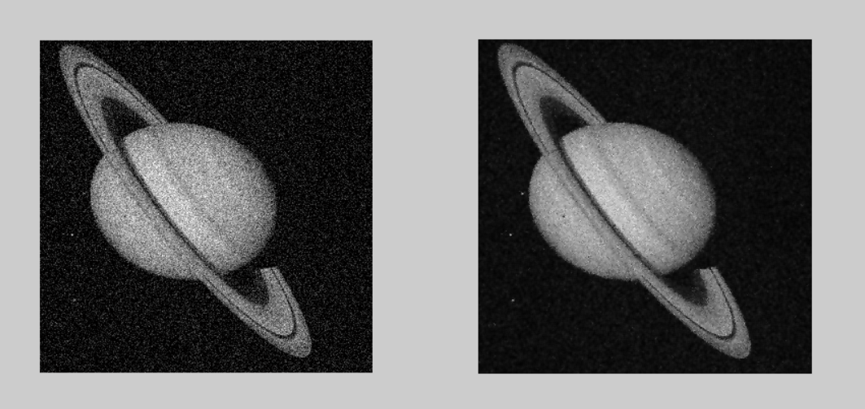

And after applying the filter, this was the result.

Then I tried using the fspecial filter with the imfillter and I got this result:

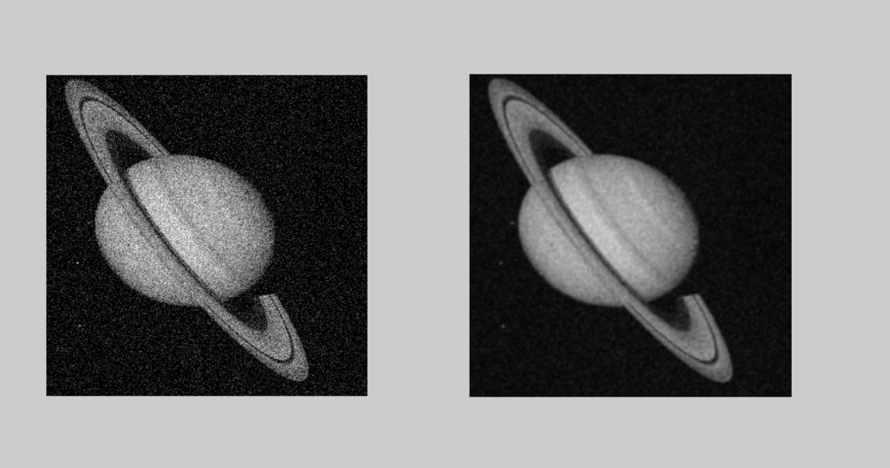

On this one, it seems that the second one has a cleaner result.

And for the second image, the problem was that it had the ‘salt and pepper’ filter on, and to fix the image all I had to do was apply the medfilt2 filter to the image:

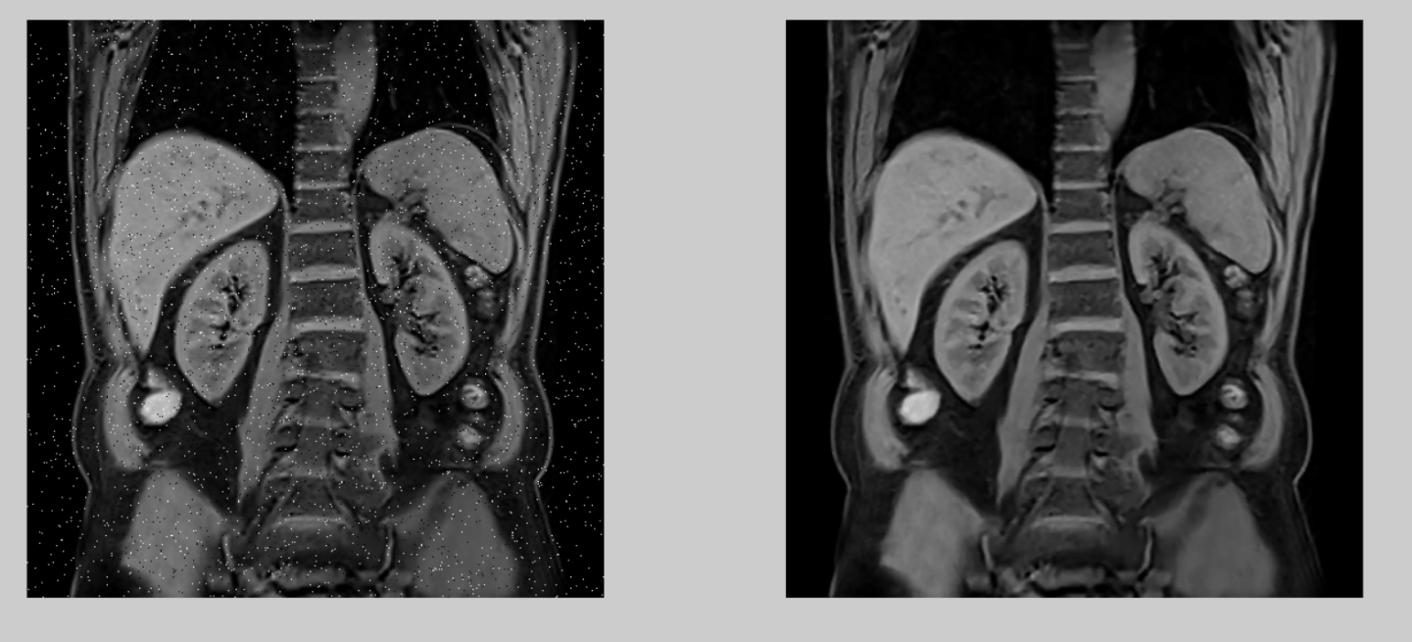

And for the third image, I found that the original image was washed out, and needed better intensity transformations. So by comparing between the inverse log, and the gamma filters, I found that the gamma filter is better suited for this situation. And I used a gamma of 1.6:

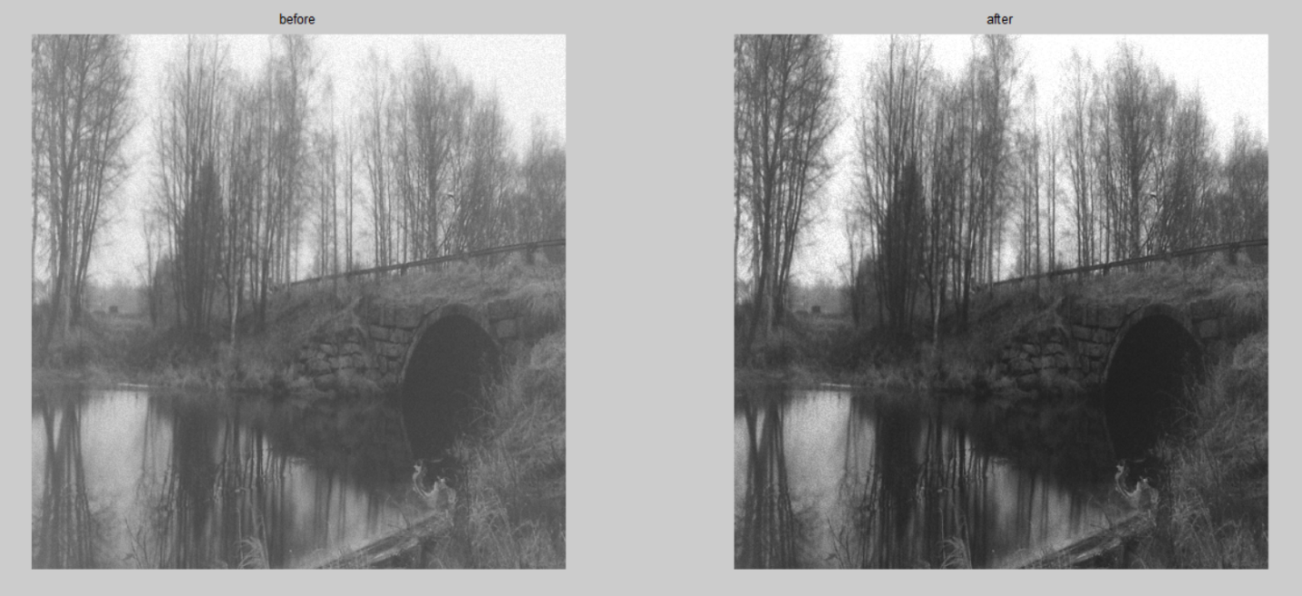

And also, for image three, i thought we could also use the contrast stretching to have a similar result by using the filter imadjust:

